WORK HOLDING VICES

PRECISION MACHINE VICES
We are a leading Supplier of Precision Machine Vices such as Precision Sine Vice (Screw Type), Precision Sine Table, Precision Machine Vice, Precision Quick Fit Machine Vice, Precision Horizontal Vertical Rotary Table, Precision Grinding Machine and many more items from India.

Precision Sine Vice (Screw Type)
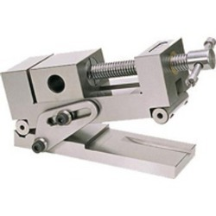
Features:
- SVS-Screw Type
- Made from tool steel hardened & ground
- Mounted on hardened & ground rollers, the vice can be inclined in the desired position with the help of side strap clamp. The recess of 1mm depth is made in base plate for low angle positioning.
Specification:
Model No. | Width (mm) | Length (mm) | Height (mm) | Net Weight (mm)
SVS-110 | 70 | 200 | 95 | 8
SVS-120 | 95 | 270 | 100 | 11

Precision Sine Vice (Pin Type)
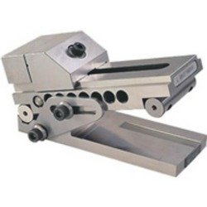
Features:
- SVS- Pin Type
- Made from tool steel hardened & ground
- Mounted on hardened & ground rollers, the vice can be inclined in the desired position with the help of side strap clamp. The recess of 1mm depth is made in base plate for low angle positioning.
Specification:
Model No. | Width (mm) | Length (mm) | Height (mm) | Net Weight (mm)
 | 70 | 180 | 95 | 4
 | 95 | 200 | 95 | 6.4

Precision Machine Vices
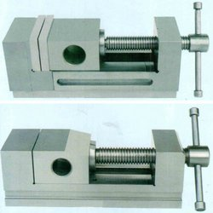
Our organization is involved in manufacturing and supplying a wide range of industrial products which includes Precision Machine Vice. These are made using supreme quality raw materials like tool steel (hardened & ground) with the help of advancedtechnology, which ensures their durability and corrosion resistance. Available in wide range of grade and sizes, these are apt for industrial use, small and big alike. Ouraggressive pricing and tamper proof packaging makes our product one of the most sought after in the market.

High Pressure Hydraulic Machine Vice
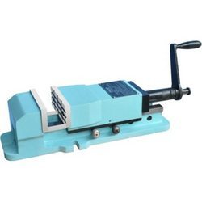
We are engaged in manufacturing and supplying of a varied assortment of High Pressure Hydraulic Machine Vice. These handy vices are manufactured using supreme quality raw materials and used in array of applications. Few of its attributes are durability, toughness, Unbreakable steel body, supreme performance and corrosion resistance. Made from latest equipments and modern design, these vices are available with lock down mechanism, clamping pressure 4000 kg (aprox), No hammering and no pipe locking.
Hardened & ground slide ways adds on to the reliability while using special tool materials.
Features Of High Pressure Hydraulic Machine Vice :-
- Unbreakable steel body, hardened & ground slide ways for longer repeated accuracy
- Accuracy in squareness with in 0.02mm
- No external Hydraulic Power Pack Required
- Trouble free Performance
- Extremely Easy to clamp & un-clamp.
- No hammering, no pipe locking.
- Supplied with or without swivel base
- clamping pressure 4000 kg(aprox)
- multi start screw rods are quick movement of hydraulic jaw & clamping
- lock down mechanism for minimum cant & lift of jaws.
Model No. | Maximum Clamping Presure | Width Of Jaws | Depth Of Jaws | Opening Of Jaws | Hight With Swieval Base | HightWithoud Swieval Base | Tenon Sizes In MM
N-181 | 4000 KGS | 160MM | 67MM | 235MM | 175MM | 135MM | 16MM
N-182 | 4000 KGS | 160MM | 67MM | 300MM | 175MM | 135MM | 16MM
N-183 | 9000 KGS | 200MM | 80MM | 300MM | 230MM | 180MM | 18MM

Self Centering Vice
Providing you the best range of Self Centering Vice such as Self Centering Machine Vice and Self Centering Shaft Vice with effective & timely delivery.

Self Centering Machine Vice
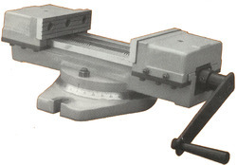

Specifications
Jaw – Width 160mm
Jaw – Depth 56mm

Jaw – Opening (max) 300mm
Range-I 0-165mm
Range-II 70-200mm
Range-III 166-300mm

Overall Size:
Height 180mm
Width 350mm
Length (max) 900mm
Length (min) 600mm

Clamping Force (max) 5000Kgf
Weight 76Kgs.

Self Centering Vice
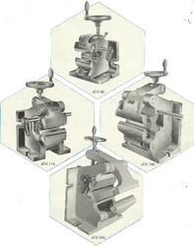
The self-centering vice is very essential for doing precision jobs such as milling of accurate radial grooves and slots in round components as well as for drilling radial holes. The vices shown in this leaflet have two bases at right angles to each other which facilitate their being used both in horizontal and vertical positions. Both the bases are provided with T- slot tongues.

A single alignment on machine is enough for all work piece diameters. Once set, the central position remains constant even if the diameter of the job varies. The adjustable length stop facilitates the accurate determination of distances and the distance remains uncharged, which makes uninterrupted production.

Specifications

Description | Dimensions in mm
Description | JCV 90 | JCV 110 | JCV 180 | JCV 240
Diameter Range | 6 to 150 mm | 10 to 80 mm | 50 to 150 mm | 100 to 250 mm
Width of jaws | 90 mm | 110 mm | 180 mm | 240 mm
Vertical base L x W | 180 x 135 mm | 200 x 145 mm | 280 x 185 mm | 350 x 255 mm
Horizontal base L x W | 180 x 150 mm | 200 x 185 mm | 280 x 270 mm | 385 x 350 mm
Weight (Approx) | 15 Kgs. | 25 Kgs. | 50 Kgs. | 130 Kgs.

Self Centering Shaft Vice
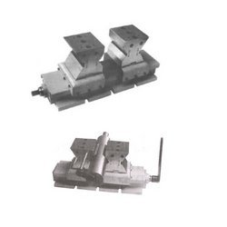

With wide and rich industrial experience, we are offering supreme quality Self Centering Shaft Vice. Manufactured using latest technology and machinery, these are of world class standards. Perfect for all types of industrial uses, these vices are made fromclose grained high grade cast iron with brinnel hardness of 180 and above, alloy steel and nuts made from phosphor bronze. Ours quality and competitive pricing are one of the best in the market.

Specifications | JSV-100 | JSV-200
Diameter range | 10 to 100 | 50 to 200
Width of V-Blocks | 100 | 125
Centre height | 155 | 185
Overall height | 200 | 250
Base area L X B | 380 X 150 | 500 X 175
Weight (approx) | 50 kgs | 75 kgs

SELF CENTERING VICE
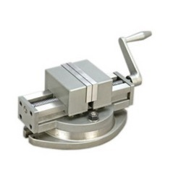
We also hold the expertise in manufacturing self centering vice. These are made from a very high grade metals due to which they are in great demand in the global market. Our metallurgical analysis and expertise in this field helps us produce very durable, tough, and chemical and corrosion resistance vices with a very high tensile strength. Available in all shapes and sizes, these are very much suitable for all industrial use. Along with aggressive pricing and safe packing, it’s a value for money for our customers.
Model No. | JAWS WIDTH | JAWS DEPTH | JAWS OPENING | SWIVEL RANGE | APPROX. HEIGHT | WEIGHT (IN kgs)
SCV - 100 | 100 | 40 | 100 | 360" | 122 | 14.5
SCV - 125 | 125 | 46 | 125 | 360" | 140 | 26
SCV - 150 | 150 | 48 | 150 | 360" | 170 | 37

3 Way Universal Tilt & Swivel Angle Vice
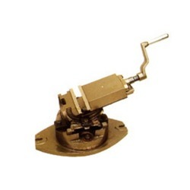
We are one of the leading manufacturer and supplier of the finest quality 3 Way Universal Tilt & Swivel Angle Vice. Known for their toughness and heavy duty performance, these vices are available with ACME steel screw, accurately ground jaws provided with 'V' groove and unbreakable steel crank handle. Our vices are very cost-effective and come in variety of sizes.
Specifications:-
 | Size In Inches | 4 | 6
A | Width of jaws in mm | 100 | 150
B | Opening of jaws in mm | 100 | 150
C | Depth of jaws in mm | 38 | 52
D | Overall Height in mm | 195 | 285
E | overall Lenght in mm | 450 | 530
 | Base Tenon slot in mm | 20 | 20
 | Weight (Approx.) in kgs. | 30 | 62

UNIVERSAL BALL VICE
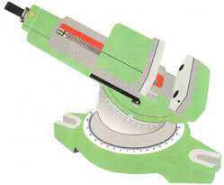
Specifications | TYPE  BR. UBV-140
Width of jaws | 140mm
Depth of jaws | 45mm
jaws opening range | 0-150mm
Overall height | 225mm
Center to center of clamping slots | 285mm
Tenon slots | 14mm
Swiveling in Vertical plane | 45°
Swiveling in Horizontal plane | 360°
Weight (App.) | 40. Kg

Angular Machine vice
Supplier of Angular Machine Vice & Angular Omni Machine Vice. Our product range also comprises of Inspection Equipments, Measuring Tools and Magnetic Products.

Angular Machine Vice
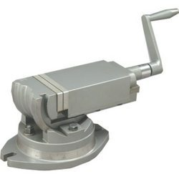

We are engaged in manufacturing and supplying of a varied assortment of Milling Machine Vices. We offer superior quality of milling machine vices, which are manufactured from high grade special alloys and provide customers with maximum durability. Apt for all industrial uses, these vices are available in various specifications which are known for their high torques and quality finish. With safe packaging and competitive price, these are in high demand in international market.

Model No. | Jaws Width | Jaws Depth | Jaws Opening | Swivel Range | Vertical Indexing | Approx. Height | Weight (in kgs.)
AMV-50 | 50 | 23 | 50 | 360” | 0 TO 90” | 92 | 3.2
AMV-75 | 75 | 35 | 75 | 360” | 0 TO 90” | 125 | 9.5
AMV-100 | 100 | 38 | 100 | 360” | 0 TO 90” | 140 | 16.5
AMV-125 | 125 | 45 | 125 | 360” | 0 TO 90” | 180 | 32
AMV-150 | 150 | 48 | 150 | 360” | 0 TO 90” | 187 | 39

Angular Omni Machine Vice
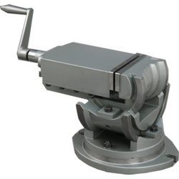

We offer a comprehensive range of angular omni machine vice, fabricated from finest quality of raw material. This range of angular omni machine vices is available in different specifications. These machine vice are extensively used in various mechanical operations. Our latest technology equipped manufacturing unit and qualified engineers ensures that we make latest design vices with increasing toughness and durability with swivel range of 360°.

Model No. | Jaws Width | Jaws Depth | Jaws Opening | Swivel Range | Vertical Indexing | Tilting Range | Approx. Height | Weight (in kgs.)
AOMV-50 | 50 | 23 | 50 | 360” | 0 TO 90” | 45” | 115 | 4
AOMV-75 | 75 | 35 | 75 | 360” | 0 TO 90” | 45” | 157 | 9
AOMV-100 | 100 | 38 | 100 | 360” | 0 TO 90” | 45” | 188 | 19
AOMV-125 | 125 | 45 | 125 | 360” | 0 TO 90” | 45” | 235 | 36
AOMV-150 | 150 | 48 | 150 | 360” | 0 TO 90” | 45” | 254 | 49

Milling Machine Vice

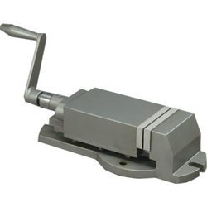

Model No. | Jows Width | Jaws Depth | Jaws opening | Swivel Range | Approx. Height | Weght  ( in kgs )
MMV-50 | 50 | 23 | 50 | 360° | 51 | 2
MMV-75 | 75 | 35 | 75 | 360° | 75 | 6.4
MMV-100 | 100 | 38 | 100 | 360° | 84 | 13
MMV-125 | 125 | 45 | 125 | 360° | 102 | 22
MMV-150 | 150 | 48 | 150 | 360° | 108 | 31.5
MMV-200 | 200 | 58 | 200 | 360° | 127 | 57

Milling Swivel Vice
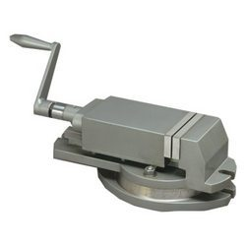
We offer a wide assortment of Milling Swivel Vice. Available in endless varieties of different specifications, these are fabricated using highest quality raw materials with international standard. These milling swivel vices are durable, heavy duty and corrosion resistant. Customers can avail benefits of industry leading price and latest of design which ensure maximum result with minimum of effort.
Model No. | Jows Width | Jaws Depth | Jaws Qoening | Swivel Range | Approx. Height | Weght ( in kgs )
MVS-50 | 50 | 23 | 50 | 360° | 76 | 3
MVS-75 | 75 | 35 | 75 | 360° | 102 | 9
MVS-100 | 100 | 38 | 100 | 360° | 115 | 17
MVS-125 | 125 | 45 | 125 | 360° | 139 | 31
MVS-150 | 150 | 48 | 150 | 360° | 143 | 39
MVS-200 | 200 | 58 | 200 | 360° | 175 | 77

ROTARY HEAD VICE

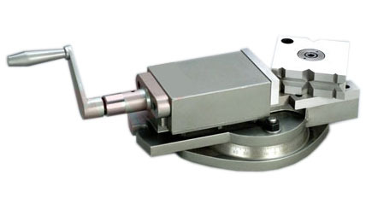

Model | JAWS WIDTH | JAWS OPENING
RHV – 101 | 100 | 100
RHV- 102 | 120 | 120
RHV -103 | 145 | 145

